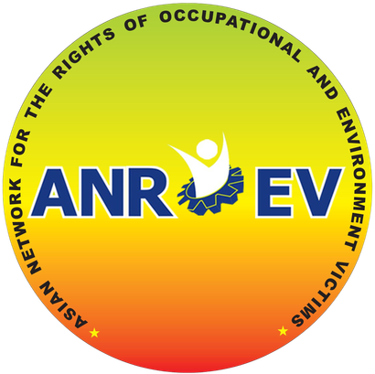

Small Grant for EHS Pilot Project (2026) Application Form
Please fill out the information requested in the form. To complete your application must save and send the file as a PDF to AMRC amrc@amrcentre.org and Nadia De Leon anroevcoordinator@gmail.com (no more than 3 pages)

Deadline: April 10, 2026 1800 KST

Organizational Profile
Organization Name:
Contact Person (Name/ email):
Country:

Project Context
Project Title:
Target Location: (if BRI-related, specify the investment project name and location) Thematic Focus: (e.g., Coal-Fired Power Plant, air quality, water contamination)
Target group/ Direct beneficiaries: (Identify groups and estimated number)

Project Description & Content
Problem Statement: Briefly describe the specific environmental and health hazards the community is facing.
Project Objectives:What do you hope to achieve regarding victim empowerment and advocacy? Detailed Activities: Describe your planned actions for research/monitoring, community meetings,
and campaign launches.
Expected Outputs & Outcomes: (List maximum 2 or 3)

Strategy and Implementation
Monitoring Plan: Which environmental indicators will you monitor (e.g., air, water, or noise)? Organizing & Outreach: How will you empower victims and organize the community
Advocacy & Sharing: How will you share results through ANROEV’s regional platforms for dialogue?

Budget & Timeline Summary
Total Requested: (Max USD 3,000)
Activity Schedule: (Monthly plan from April to September 2026)

